**Soal Prioritas 1**

Aplikasi yang dibangun menggunakan Flutter:

* Google Stadia, Google Ads, Google Assistant  
  
* Ebay Motors  
  
* SpaceX Go  
  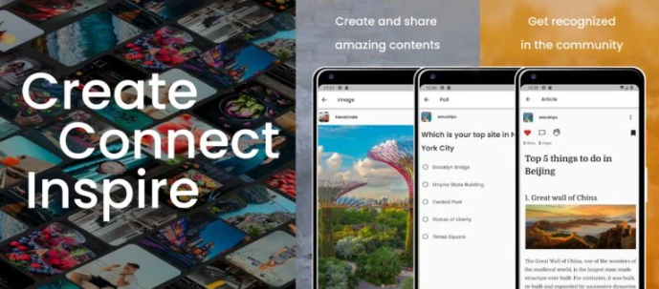

**Flutter Doctor  
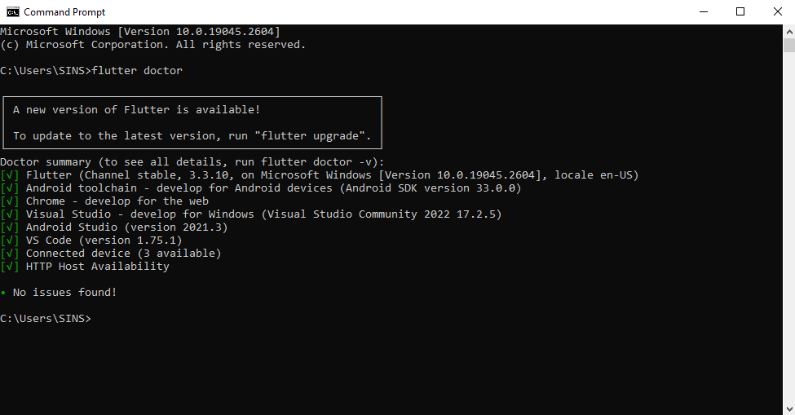**

**Create & Run Flutter App  
